 NIT KURUKSHETRA

NAME:- JITENDRA KUMAR DUBEY

COURSE:- MCA (1ST Sem)

ROLL NUM:- 52112105

SUBJECT :- FOM

:- CASE STUDY ABOUT GOOGLE DOCS

GOOGLE DOCUMENTS (DOCS) :

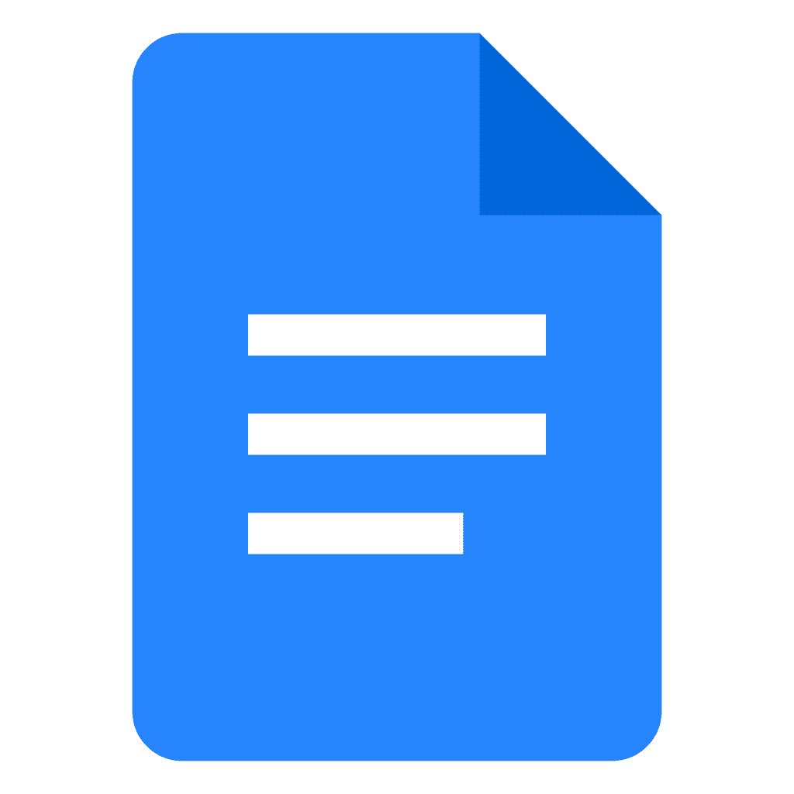 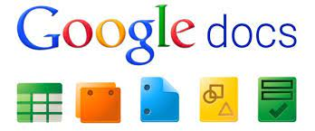

*This is a free Online Documents editor .*

FOUNDER OF GOOGLE DOCS:-   **“SAM SCHILLACE”**  

If Google Docs is the mother of modern word processing, **Sam Schillace** is probably its father. Back in 2005 he built Writely, a web-based text editor, which Google acquired in 2006. One month later, 90 percent of the company was using it. Writely formed the foundation of Google Docs, a product Schillace led for years before heading to Box to be its senior vice president of engineering and take on the next age of online collaboration.

Google Docs is a free Web based [application](https://searchsoftwarequality.techtarget.com/definition/application) in which [documents](https://whatis.techtarget.com/definition/document) and [spreadsheets](https://whatis.techtarget.com/definition/spreadsheet) can be created, edited and stored online. Files can be accessed from any computer with an Internet connection and a full-featured Web [browser](https://whatis.techtarget.com/definition/browser). Google Docs is a part of **a** comprehensive package of Users of Google Docs can import, create, edit and update documents and spreadsheets in work may not be private or secure various [fonts](https://whatis.techtarget.com/definition/font) and file formats, combining text with formulas, lists, tables and images. Google Docs is compatible with most [presentation software](https://whatis.techtarget.com/definition/presentation-software-presentation-graphics) and [word processor](https://searchwindowsserver.techtarget.com/definition/word-processor) applications. Work can be published as a Web page or as a print-ready manuscript. Users can control who sees their work. Google Docs is ideal for publishing within an enterprise, maintaining [blogs](https://whatis.techtarget.com/definition/blog) or composing work for viewing by the general public.

Google Docs lends itself to collaborative projects in which multiple authors work together in [real time](https://whatis.techtarget.com/definition/real-time) from geographically diverse locations. All participants can see who made specific document changes and when those alterations were done. Because documents are stored online and can also be stored on users' computers, there is no risk of total data loss as a result of a localized catastrophe. However, the Internet-based nature of Google Docs has given rise to concerns among some authors that their work may not be private or secure online applications offered by and associated with Google. Users of Google Docs can import, create, edit and update documents and spreadsheets in various [fonts](https://whatis.techtarget.com/definition/font) and file formats, combining text with formulas, lists, tables and images. Google Docs is compatible with most [presentation software](https://whatis.techtarget.com/definition/presentation-software-presentation-graphics) and [word processor](https://searchwindowsserver.techtarget.com/definition/word-processor) applications. Work can be published as a Web page or as a print-ready manuscript. Users can control who sees their work. Google Docs is ideal for publishing within an enterprise, maintaining [blogs](https://whatis.techtarget.com/definition/blog) or composing work for viewing by the general public.

**History of Google Docs :-**

Google Docs originated from two separate products: Writely and XL2Web. Writely was a [web-based](https://en.wikipedia.org/wiki/Web_application) [word processor](https://en.wikipedia.org/wiki/Word_processor) created by the software company Upstartle and launched in August 2005.

[[2]](https://en.wikipedia.org/wiki/Google_Docs#cite_note-2) It began as an experiment by programmers Sam Schillace, Steve Newman and Claudia Carpenter, trying out the then-new [Ajax](https://en.wikipedia.org/wiki/Ajax_(programming)) technology and the "content editable" function in browsers.

[[3]](https://en.wikipedia.org/wiki/Google_Docs#cite_note-3) On March 9, 2006, Google announced that it had acquired Upstartle.

[[4]](https://en.wikipedia.org/wiki/Google_Docs#cite_note-4) In July 2009, Google dropped the [beta testing status](https://en.wikipedia.org/wiki/Software_release_life_cycle#Beta) from Google Docs.

[[5]](https://en.wikipedia.org/wiki/Google_Docs#cite_note-6) In March 2010, Google acquired DocVerse, an online document collaboration company. DocVerse allowed multiple user online collaboration on [Microsoft Word](https://en.wikipedia.org/wiki/Microsoft_Word) documents, as well as other [Microsoft Office](https://en.wikipedia.org/wiki/Microsoft_Office) formats, such as [Excel](https://en.wikipedia.org/wiki/Microsoft_Excel) and [PowerPoint](https://en.wikipedia.org/wiki/Microsoft_PowerPoint).

[[6]](https://en.wikipedia.org/wiki/Google_Docs#cite_note-7) Improvements based on DocVerse were announced and deployed in April 2010.

[[7]](https://en.wikipedia.org/wiki/Google_Docs#cite_note-8) In June 2012, Google acquired [Quickoffice](https://en.wikipedia.org/wiki/Quickoffice), a freeware proprietary productivity suite for mobile devices.

[[8]](https://en.wikipedia.org/wiki/Google_Docs#cite_note-9) In October 2012, Google renamed the [Drive](https://en.wikipedia.org/wiki/Google_Drive) products and Google Documents became Google Docs. At the same time, [Chrome apps](https://en.wikipedia.org/wiki/Chrome_app) were released, which provided shortcuts to the service on Chrome's new tab page.

[[09]](https://en.wikipedia.org/wiki/Google_Docs#cite_note-10) In February 2019, Google announced grammar suggestions in Docs, expanding their spell check by using machine translation techniques to help catch tricky grammatical errors.

**Availabillity of Google docs :-**

:- Google Docs is available as a [web application](https://en.wikipedia.org/wiki/Web_application) supported on [Google Chrome](https://en.wikipedia.org/wiki/Google_Chrome), [Mozilla Firefox](https://en.wikipedia.org/wiki/Firefox), [Internet Explorer](https://en.wikipedia.org/wiki/Internet_Explorer), [Microsoft Edge](https://en.wikipedia.org/wiki/Microsoft_Edge), and [Apple](https://en.wikipedia.org/wiki/Apple_Inc.) [Safari](https://en.wikipedia.org/wiki/Safari_(web_browser)) web browsers.

:- Users can access all Docs, as well as other files, collectively through the [Google Drive](https://en.wikipedia.org/wiki/Google_Drive) website. In June 2014, Google rolled out a dedicated website homepage for Docs, that contains only files created with the service.

:-  In 2014, Google launched a dedicated mobile app for Docs on the [Android](https://en.wikipedia.org/wiki/Android_(operating_system)) and [iOS](https://en.wikipedia.org/wiki/IOS) mobile operating systems.

:- The mobile website for Docs was updated in 2015 with a "simpler, more uniform" interface, and while users can read files through the mobile websites, users trying to edit will be redirected towards the dedicated mobile app, thus preventing editing on the mobile web.

NECESSITY OF GOOGLE DOCS :-

1.Before Google docs most of the word processing task perform on “MS WORD” type softwares this is a window accessible software. In the morden era most of the people have smart phone and they always have mobile in their pocket not laptop.

“We can access GOOGLE DOCS anywhere we have only our phone and net connection ”.

2. In the last 2 year google docs play very important role in our life ( COVID PANDEMIC ) all the work of Schools,College,offices etc shift on googl;e docs.

3. For online presenting any documantaion google docs req.

**GOOGLE DOCS FEATURES:-**

1.EDITING

2.EXPLORE

3.FILES

4.GOOGLE WORKSPACE

1. EDITING:-

Google Docs and the other apps in the Google Drive suite serve as a collaborative tool for cooperative editing of documents in real-time. Documents can be shared, opened, and edited by multiple users simultaneously and users are able to see character-by-character changes as other collaborators make edits. Changes are automatically saved to Google's servers, and a revision history is automatically kept so past edits may be viewed and reverted to.An editor's current position is represented with an editor-specific color/cursor, so if another editor happens to be viewing that part of the document they can see edits as they occur. A sidebar chat functionality allows collaborators to discuss edits.

2. **EXPLORE :-**

In March 2014, Google introduced add-ons, new tools from third-party developers that add more features to Google Docs. In order to view and edit documents offline on a computer, users need to be using the Google Chrome web browser. A Chrome extension Google Docs Offline', allows users to enable offline support for Docs files on the Google Drive website.The Android and iOS apps natively support offline editing.

3.**FILES:-**

Supported file formats:

Files in the following formats can be viewed and converted to their Docs format.

For formatted text documents: OpenDocument, Rich text format, zipped HTML, Unicode plain text, Microsoft Word.

File limits:-

Limits to insertable file sizes, overall document length and size are listed below:

Up to 1.02 million characters, regardless of the number of pages or font size. Document files converted to .gdoc (Docs) format cannot be larger than 50 MB. Images inserted cannot be larger than 50 MB, and must be in either .jpg, .png, or .gif formats.

**4. GOOGLE WORKSPACE:-**

Google Docs and the Google Docs Editors suite are free of charge for use by individuals, but are also available as part of Google's business-centered Google Workspace, enabling additional business-focused functionality on payment of a monthly subscription.

**OTHER FUNCTIONALITY OF GOOGLE DOCS:-**

A simple find and replace tool is available. Google offers an extension for the Google Chrome web browser called Office editing for Docs, Sheets and Slides that enables users to view and edit Microsoft Word documents on Google Chrome via the Docs app. The extension can be used for opening Office files stored on the computer using Chrome, as well as for opening Office files encountered on the web (in the form of email attachments, web search results, etc.) without having to download them. The extension is installed on Chrome OS by default. Google Cloud Connect was a plug-in for Microsoft Office 2003, 2007 and 2010 that could automatically store and synchronize any Word document to Google Docs (before the introduction of Drive) in Google Docs or Microsoft Office formats. The online copy was automatically updated each time the Microsoft Word document was saved. Microsoft Word documents could be edited offline and synchronized later when online. Google Cloud Connect maintained previous Microsoft Word document versions and allowed multiple users to collaborate by working on the same document at the same time.Google Cloud Connect was discontinued in April 2013 as, according to Google, Google Drive achieves all of the above tasks, "with better results".

SOME ISSUE ALSO GENERATE WITH GOOGLE DOCS :-

1.Phising attack :-

In May 2017, a phishing attack impersonating a Google Docs sharing email spread on the Internet. The attack sent emails pretending to be someone the target knew, requesting to share a document with them. Once the link in the email was pressed, users were directed to a real Google account permissions page where the phishing software, a third-party app named "Google Docs", requested access to the user's Google account. Once granted, the software received access to the user's Gmail messages and address book, and sent new fraudulent document invitations to their contacts. The phishing attack was described by media outlets as "massive" and "widespread".

### 2. **"Terms of Service" error:-**

n October 2017, Google released a server-side update to its codebase, which started incorrectly flagging random documents as unspecified violations of its "Terms of Service" policies. A fix was released shortly afterwards, though the issue became noteworthy for the extent of Google's control over users' content, including its analysis of the contents of documents, as well as for its ability to shut users out at any time, including during critical moments of work.

**Google docs users graph:-**

Google docs graph is increase day by by because of some reason:

1.It’s free of cost.

2.No manual saves.

3.File Names are not concern4.

4.Easily Accesibble Anywhere 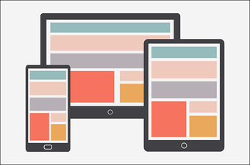

5.zero corrupt files.

6.Highly Compatible

**CONCLUSION:-**

Since Google docs so many advance features like as speak,do not type, collaborating is a breeze, Research&Link Directly.Google Docs could be access without internet here we can check our save data at any time. And it is accessible via chrome. Changes are synced everywhere . These are the advantage of using Google Docs so peoples are comfortable with google docs. It play a very important role in COVID PANDEMIC SITUATION.

REFERNCES:-

1. Duddu, Sarveshwar (May 15, 2012). [*"Find facts and do research inside Google Documents"*](https://cloud.googleblog.com/2012/05/find-facts-and-do-research-inside.html). Official Google Cloud Blog*. Retrieved December 14, 2016*.
2. [**^**](https://en.wikipedia.org/wiki/Google_Docs#cite_ref-25) Robertson, Adi (May 15, 2012). [*"Google Docs Research sidebar looks up terms, adds images, quotes, and citations"*](https://www.theverge.com/2012/5/15/3022223/google-docs-research-toolbar-launched). [*The Verge*](https://en.wikipedia.org/wiki/The_Verge). [*Vox Media*](https://en.wikipedia.org/wiki/Vox_Media)*. Retrieved December 14, 2016*.
3. [**^**](https://en.wikipedia.org/wiki/Google_Docs#cite_ref-26) Weber, Harrison (May 15, 2012). [*"Useful! Google Docs introduces new sidebar research tool"*](https://thenextweb.com/apps/2012/05/15/useful-google-docs-introduces-new-sidebar-research-tool/). The Next Web*. Retrieved December 14, 2016*.
4. [**^**](https://en.wikipedia.org/wiki/Google_Docs#cite_ref-27) Ranjan, Ritcha (September 29, 2016). [*"Explore in Docs, Sheets and Slides makes work a breeze — and makes you look good, too"*](https://docs.googleblog.com/2016/09/ExploreinDocsSheetsSlides.html). Google Docs Blog*. Retrieved December 16, 2016*.
5. [**^**](https://en.wikipedia.org/wiki/Google_Docs#cite_ref-28) Novet, Jordan (September 29, 2016). [*"Google updates Calendar, Drive, Docs, Sheets, and Slides with machine intelligence features"*](https://venturebeat.com/2016/09/29/google-updates-calendar-drive-docs-sheets-and-slides-with-machine-intelligence-features/). [*VentureBeat*](https://en.wikipedia.org/wiki/VentureBeat)*. Retrieved December 16, 2016*.
6. [**^**](https://en.wikipedia.org/wiki/Google_Docs#cite_ref-29) Allan, Darren (September 30, 2016). [*"Google wants to better challenge Microsoft Office with these new features"*](http://www.techradar.com/news/software/google-wants-to-better-challenge-microsoft-office-with-these-new-features-1329658). [*TechRadar*](https://en.wikipedia.org/wiki/TechRadar). [*Future plc*](https://en.wikipedia.org/wiki/Future_plc)*. Retrieved December 16, 2016*.
7. [**^**](https://en.wikipedia.org/wiki/Google_Docs#cite_ref-30) [*"Quickly and easily cite your sources with Explore in Google Docs"*](https://gsuiteupdates.googleblog.com/2016/12/quickly-and-easily-cite-your-sources.html). G Suite Updates. December 5, 2016*. Retrieved December 6, 2016*.
8. [**^**](https://en.wikipedia.org/wiki/Google_Docs#cite_ref-31) Palmer, Jordan (December 5, 2016). [*"Explore in Google Docs gets new quick source citations"*](http://www.androidpolice.com/2016/12/05/g-suite-adds-quick-source-citations/). Android Police*. Retrieved December 6, 2016*.
9. [**^**](https://en.wikipedia.org/wiki/Google_Docs#cite_ref-32) Garun, Natt (December 5, 2016). [*"Google Docs adds a quick citation button just in time for finals season"*](https://www.theverge.com/2016/12/5/13848744/google-docs-g-suite-quick-citation-tool). [*The Verge*](https://en.wikipedia.org/wiki/The_Verge). [*Vox Media*](https://en.wikipedia.org/wiki/Vox_Media)*. Retrieved December 6, 2016*.
10. [**^**](https://en.wikipedia.org/wiki/Google_Docs#cite_ref-33) [*"Work with Office files"*](https://support.google.com/docs/answer/6055139). Docs editors Help. Google Inc*. Retrieved October 30, 2016*.
11. [**^**](https://en.wikipedia.org/wiki/Google_Docs#cite_ref-34) [*"Files you can store in Google Drive"*](https://support.google.com/drive/answer/37603). Drive Help. Google Inc*. Retrieved October 22, 2016*.